Response to the Draft Strategy Plan for the World Heritage Environs Area
Royal Exhibition Building and Carlton Gardens
22 September 2021

Introduction
The Royal Historical Society of Victoria had been awaiting the Draft Strategy Plan (DSP) with keen anticipation. We are pleased that in almost all respects it does not disappoint. Our eagerness was fuelled by the Discussion Paper issued early last year, which succeeded in identifying the many deficiencies of the current system of controlling development in the WHEA and which canvassed a number of possible solutions. We are pleased to find that the more promising of these ideas have survived through to the Draft Strategy Plan itself. The RHSV strongly supports the thrust of the DSP.

The RHSV is the peak body for Victoria’s 340 local history societies and a key stakeholder with the City of Melbourne since the Society’s inception in 1909. As stakeholders with regard to the World Heritage site of the Royal Exhibition Building and the Carlton Gardens, we were deeply involved with and supportive of the initial Discussion Paper.

The significance of this site, taken as a whole—the Royal Exhibition Building, the Carlton Gardens and the environs, still largely suggestive of the kinds of built forms predominating at the time of the 1880 Exhibition—cannot be overestimated. ‘There is nothing like it anywhere else in the world today’, wrote the eminent UK historian, Professor David Cannadine. As the Australian Government Response to the ICOMOS Assessment Report put it in 2004: ‘The Royal Exhibition Building in its original garden setting is the most authentic remaining example of an in situ Palace of Industry from a significant international exhibition’. All that makes the site of the utmost value to Victoria and particularly to Melbourne.

We have identified five initiatives in the Strategy Plan and have used these as headings to structure our response. We have also identified a further issue, that of governance, which seems to be missing in the plan. These headings are:

1.The Removal of the distinction between the Area of Greater Sensitivity and the rest of the WHEA.

2. The views to the tower of the Royal Exhibition Buildings that need to be protected and the significance of the outlook from the viewing platform at the Tower.

3. The proposed WHEA boundary extensions.

4. The appointment of a Determining Referral Authority

5. The proposed planning controls

6. The future governance of the World Heritage Site

1. Area of Greater Sensitivity
As set out in our response to the Discussion Paper, the RHSV strongly supports the recommendation to remove the distinction between areas of greater and lesser sensitivity so that the WHEA is managed as one buffer zone. The world heritage provisions in the current Melbourne and Yarra planning schemes relate only to the Area of Special Sensitivity; this makes a mockery of the designation of the remainder of the WHEA.

As we also noted in our response, removal of the distinction brings planning provisions into line with promises the Australian Government made to UNESCO in seeking World Heritage nomination for the site. The introduction of the distinction in 2009 made possible the construction of a number of towers that threaten the World Heritage values of the site. It is evident from current development proposals that the more specific controls proposed in the Draft Strategy Plan are urgently required to prevent further and possibly greater threats, and that these controls must be applied to the whole of the WHEA.

2. Protection of Views
We support protection of the views of the tower through the process set out in the DSP. The exploration and identification of the views that may need protection outlined there appears thorough and extensive.

We also support protection of views from the REB itself. It is good to see that for the first time these views are being considered, especially now that the reconstruction of the viewing platform has been completed. In contrast to the slot views from within the WHEA, the valued views from the tower are wide vistas over the predominantly lower scale form of development to the east, north and west. The existing and proposed Design and Development Overlays should be effective in maintaining the character of these vistas, which, for the most part, retain the form and appearance close to that which existed at the time of the REB’s construction. We therefore support the proposed DDOs.

While high-rise development has been allowed to encroach into the WHEA to the south, it is good to see that the DSP has considered the views towards the city from the forecourt immediately to the north of the REB. An extension of the WHEA to the south-west is proposed so that design controls can ensure that, in key views from the forecourt, the building will not be overwhelmed by city towers rising above the ridgeline. We support that extension, as we make clear below.

3. WHEA Boundary Extensions
We strongly and emphatically support the three proposed extensions to the WHEA boundary. In the case of the East extension, we call for further extension to Brunswick Street. In doing so, we emphasise the need not only for the protection of views, but also for the protection of World Heritage values throughout the urban fabric relevant to the 1880 and 1888 Exhibitions.

1. Extension South: to include the area bounded by La Trobe, Russell, Victoria and Exhibition Streets.

As noted above, the southern extension allows for a new DDO to protect the skyline of the REB as seen from the northern forecourt. We note that there are two versions of height controls proposed for the area, Preferred height controls and Mandatory height controls. Figure 11 indicates that the Preferred height controls offer full concealment whereas the Mandatory controls are 10 metres higher and will be visible above the roof line of the REB. Given the World Heritage significance of the building and its setting, it is difficult to understand why the Mandatory controls should not be set at the full concealment level.

2. Extension West: to include properties fronting the west side of Lygon Street.

The western extension makes sense. Managing this outstanding heritage street as a whole will significantly improve the World Heritage values of the site.

3. Extension East: to include east side of Fitzroy Street road reserve (DSP Proposal) or to Brunswick Street (RHSV Proposal).

We support the proposed extension, but we consider that a further extension is required to incorporate properties on each side of Gertrude Street between Fitzroy and Brunswick Street, for two reasons:

First, the view of the tower from the corner of Gertrude and Brunswick Street is shown on Figure 9 as a Category I View. If this is to be protected, the same controls that are proposed for Gertrude Street inside the WHEA should apply along this part of the street.

Second, the proposed extension is not logical. It incorporates the road reserve. But if the reserve is included, why should the extension not be applied to properties on the east side of Fitzroy Street, to Brunswick Street? The area from Nicholson to Brunswick Street and from Gertrude to Johnston Street is a coherent area which since 1978 has constituted the South Fitzroy Heritage Precinct (HO 334). There is not only planning logic to ensuring that the WHEA is concomitant with this Precinct. There is also historical logic to this extension in that the area constitutes a coherent development relevant to the 1880 and 1888 Exhibitions. And there is touristic value to this extension logic too in that the experience of tourists visiting the World Heritage site should be protected throughout the supporting precinct.

4. Appointment of Heritage Victoria as Determining Referral Authority
We fully support the appointment of Heritage Victoria as a determining referral authority and consider the trigger threshold of any building over 11 metres to be about right. Once the DDO heights have been settled, this threshold may need to be fine-tuned.

We also believe that increased resources both in skills and staff will be required if Heritage Victoria is to accept this role. We have been disappointed to find that, in relation to a proposed development at 1–9 Gertrude Street, when notice was given to the Executive Director, as required by DDO8 in the Yarra Planning scheme, the ED, while being an objector to the development, did not feel able to participate in the subsequent appeal.

We therefore urge that, in the final recommendations, it be noted that the further role of Heritage Victoria as determining authority for the WHEA will require additional, dedicated resources.

We have used the term ‘Heritage Victoria’ as that is the term used in the draft controls. However we note that the DSP uses the term ‘Executive Director’ for the proposed referral authority. We suspect the latter term is correct, as the Executive Director is a position created and described by the Heritage Act while Heritage Victoria is simply a business unit of DELWP.

5. Proposed Planning Controls
The main instrument proposed to control built form in the WHEA is the Design and Development Overlay. We fully agree that this is the best tool available for this purpose. We also fully support the introduction of DDOs in the residential zones to replicate and thus quarantine the current zone height controls against any state-wide change to the zoning controls. We further consider that these controls should be made mandatory.

City of Melbourne
With regard to the parts of the WHEA under the aegis of the City of Melbourne, we are disappointed that it seems not to have been possible to have more uniform height controls across the whole area. However, we appreciate that a range of different zones occur throughout the area and DDOs were already in place in the Melbourne Planning Scheme. This has resulted in the existing built form controls for the WHEA along Rathdowne Street being accepted and the recommendation to deal with the gap in DDO simply adopting the existing form of DDO 6. We consider, nevertheless, that while the height controls in the DDO are less than ideal they are not unacceptable. However, we agree strongly, with the City of Melbourne that these controls need to made mandatory.

City of Yarra
The DSP recommended controls for the Yarra Planning Scheme include a new DDO to apply to the whole of the WHEA area in the Yarra Planning Scheme, which would replace the existing DDO 8. As mentioned above, this would duplicate the existing mandatory controls for the residential areas. For the commercial zone on the north side of Gertrude Street it includes a preferred maximum height control of 11.2 metres (i.e. 3 storeys), for the area between Gertrude Street and St Vincent’s Hospital a preferred height of 13.5 metres, and for the hospital precinct itself a preferred maximum height of 46.5 metres to ‘ensure development of the St Vincent's Hospital site replicates the general maximum height of existing hospital buildings’.
While we support the general intent of these controls, we do not believe they are sufficiently specific to achieve the intended results. We therefore recommend the following specific controls for the following areas:

1. For the north side of Gertrude Street between Royal Lane and the rear of properties fronting Brunswick Street we strongly urge that the new DDO incorporate the built form controls recommended for Precinct 1 in the Gertrude Street Built Form Framework. This was designed specifically to protect the view lines of the REB tower recommended in the DSP and to provide adequate ‘breathing space’ within these view lines.

For the area between Royal Lane and Fitzroy Street the Framework requires the street wall for new development to match the height of the parapet of two-storey heritage buildings (considered to be around 8 metres) and an overall building height of 11.2 metres (Figure 1).
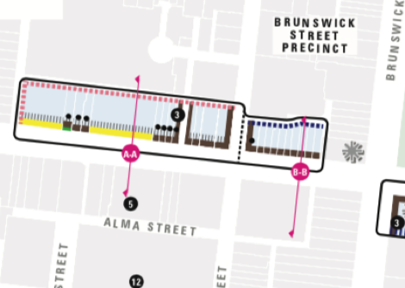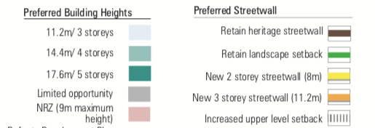
Figure 1
The recommended built form is illustrated in a cross section at page 32, which shows an 8-metre street wall with a 10-metre set back to higher development reaching 11.2 metres (incorrectly labelled 15.2 metres) and set back about 3.2 metres to the rear (Figure 2).
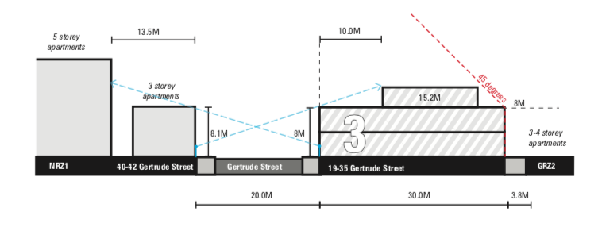
Fig. 2: Cross-section A-A

This proposal would obviously necessitate removing or amending the exemption from a planning permit for any building under 8.5 metres.

East of Fitzroy Street the cross-section is similar but with an increased street wall of 9.6 metres, a decreased upper level setback of 8 metres and no upper level setback to Marion Lane (Figure 3).
Figure 3 Cross Section B-B
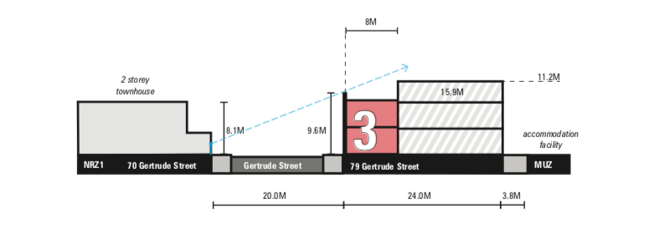

2. For the hospital precinct, rather than suggest a ‘blanket’ overall height limit, we strongly urge that the more appropriate approach would be to adopt a podium and tower form that would provide a frontage to Nicholson Street with a street wall of similar height to the proximate heritage buildings and a substantial setback of at least 10 metres. In making this suggestion we are aware that an application to demolish the Aikenhead building on the corner of Nicholson and Victoria streets and replace it with a fully glazed tower of 95 metres has been called in by the Minister for Planning and that the timing is such that any amendment to the proposed controls is unlikely to affect the decision. We make the point, however, that a tower and podium form would be the most appropriate approach if the earlier form of development and hence heritage values are to be respected. We urge the Minister to consider this in his determination.

Overall we consider that, given the world-wide significance of the heritage site and the consequent importance of the WHEA, no further justification should be required for all proposed height controls to be mandatory.

6. Future Governance
The Discussion Paper of April 2020 briefly canvassed a number of alternatives for the way in which the planning controls for the WHEA might be administered:

1. Retain the ‘status quo’ with Melbourne and Yarra Councils administering the schemes within each of their municipal boundaries.
2. Retain ‘status quo’ but with the Executive Director Heritage Victoria appointed a determining referral authority.
3. Executive Director Heritage Victoria made responsible authority for WHEA.
4. Minister for Planning made responsible authority.

The discussion paper recommended Option 2, and, as previously discussed, we support this option.

However, these options fail to deal with a significant void in the management structure for the Royal Exhibition Buildings and Carlton Gardens. There is no entity that represents the World Heritage site as a whole. At the moment this task is a part-time job for everyone involved, on top of which there is the potential for a conflict of interest to arise whenever what is in the best interest of the world heritage site is not in the best interest of the City of Melbourne, the City of Yarra, or Museums Victoria.

The site needs, and indeed deserves, a champion that will advocate for the maintenance of World Heritage Values without fear or favour. This task could involve monitoring, defending and promoting appropriate planning controls within the WHEA (we should not have to wait seven years between reviews to correct any controls that are clearly not operating in the site’s favour). But this task would extend well beyond planning controls and would involve monitoring or even undertaking the day-to-day management and promotion of the site itself.

We do not venture to propose any particular model for such an organisation, but we do seek recognition that the problem exists and needs to be addressed whether through establishing a small secretariat, perhaps within Museum Victoria or DELWP, or in a whole new stand-alone organisation. At the moment the management of the site appears like a doughnut with everyone at the periphery and nothing at the centre.
Further, we suggest that there is a need for the DSP recommendations to include clarification of the intersections between the Victorian Heritage Act, the Victorian Planning and Environment Act and the Commonwealth Environment Protection and Biodiversity Conservation Act and how their respective requirements should be managed. A recommendation on this should also be included in Section 9: Strategies for Future Management and Statutory Protection of the WHEA.

Conclusion
Given the significance of the Royal Exhibition Building and Carlton Gardens site and its importance for Melburnians and visitors alike, we believe that the effective conservation of the site and of its context—the WHEA—is the highest obligation imaginable for Melbourne and Victorian planning authorities. In line with UNESCO World Heritage standards, we are obliged to ensure that visitors drawn by the renown conferred by World Heritage status have an experience commensurate with their expectations. This review has given us the opportunity to assess the extent to which the measures in place need to be enhanced and improved in accordance with these high expectations and responsibilities. Given the current pace of development, this will be our last chance to save the site. We commend the Draft Strategy Plan and our suggested measures to improve it as a vital instrument to achieve this end.

Mr Ian Wight, MICOMOS,
Deputy Chair, Heritage Committee,
Royal Historical Society of Victoria.

‘Australian Government Response to the ICOMOS Assessment Report on the Royal Exhibition Building & Carlton Gardens World Heritage Nomination’, 9 June 2004, https://whc.unesco.org/uploads/nominations/1131bis.pdf, p. 2.
Ibid.
‘Australian Government Response to the ICOMOS Assessment Report on the Royal Exhibition Building & Carlton Gardens World Heritage Nomination’, 9 June 2004, https://whc.unesco.org/uploads/nominations/1131bis.pdf, pp. 12, 13.

